NEUMANN, Walker Buck
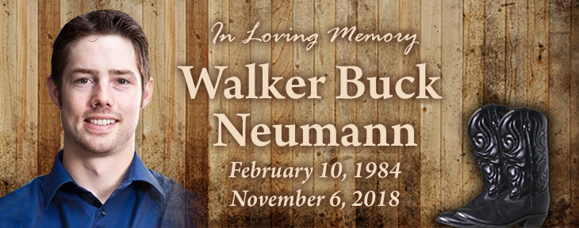
February 10, 1984 – St. Walburg, Saskatchewan
November 6, 2018 – Calgary, Alberta
Walker Neumann, beloved husband of Jacey Neumann (nee Seebach) of Foothills, AB, passed away on November 6, 2018 at the age of 34 years.
Walker was a small town farm kid who grew up with a passion for the energy industry that both his father and grandfather also worked in.
In 2007, while attending the University of Saskatchewan he met a kind, loving and wonderful woman Jacey. She captured his whole heart and on October 12, 2013 they were united in holy matrimony in Saskatoon.
Walker came to Calgary in 2008 where he found employment originally with Talisman Energy as a geologist. In 2012, Walker transferred to NuVista Energy as a senior geologist and soon was promoted to manager of Montney Development.
Walker was a kind, respected and loving man. He loved working on his acreage and spending time pulling wrenches on his classic dodges. He loved to surround himself with his family, friends and fur babies (Tango and Ruger) around a massive bon fire while sharing a drink. If Walker wasn’t tinkering with his dodges he could be found spending time outdoors quadding, sledding, camping or just spending time with the Neighbours (“The Ridge Crew”). He played hockey, loved his hunting and was a dedicated Dodge/Jeep/John Deer man through and through.
Besides his loving wife, Jacey, Walker is survived by his loving parents Dale and Colleen Neumann; his sister by heart Elissa Ellis; his brother by heart Eric Festa; his mother and father-in-law Ralph and Dodie Seebach; his childhood best friends David and Daniel Yasinski; aunts, uncles and cousin as well as the many friends that he made throughout his lifetime.
He was predeceased by his maternal grandparents Andrew and Gladys Minty; his paternal grandparents Kurt and Trudy Neumann; his great Uncle and Aunt Alfred and Alice Exner.
A Celebration of Life in honour of Walker will be held at McINNIS & HOLLOWAY (Deerfoot South, 12281 – 40th Street S.E., Calgary, AB) on Saturday, November 10, 2018 at 2:00 p.m. Reception to follow in the Hospitality Centre at the funeral home. Condolences may be forwarded through www.mcinnisandholloway.com. If friends so desire, memorial tributes may be made directly to the Canadian Mental Health Association, Alberta Division, 320 Ledgeview Business Centre, 9707 – 110 Street N.W., Edmonton, Alberta, T5K 2L9, Telephone 780-482-6576, www.alberta.cmha.ca.
In living memory of Walker Neumann, a tree will be planted at Fish Creek Provincial Park by McINNIS & HOLLOWAY FUNERAL HOMES, Deerfoot South, 12281 – 40th STREET S.E., Calgary, AB T2Z 4E6, Telephone: 403-203-0525.

